

American International University-Bangladesh (AIUB)  
**Department of Computer Science and Engineering   
Faculty of Science &Technology (FST)  
SUMMER-2021  
CSC 00191- Object Oriented Analysis And Design (OOAD)**

**Section: J**

**Project Title: PLASMA Management System.**

**Submitted by:**

|  |  |
| --- | --- |
| **Name** | **ID** |
| 1. **MINHAZ AHMED AYON** | **20-41859-1** |
| 1. **TASNOVA AHMED APON** | **20-41971-1** |
| 1. **SAJID IBNA MAHBUB** | **20-42109-1** |
| 1. **MD. IRFANUR HAQUE IFAD** | **20-42758-1** |

**Submitted to:**

**MD. ANWARUL KABIR**

**Sr. Assistant Professor**

**Department of Computer Science**

# 1. Project Title:

**PLASMA Management System.**

# 2. Project Overview:

In our Plasma management system, a citizen can request or donate plasma. First the citizen must register into the system. Then he can log in to the system anytime with the password. To donate plasma a citizen must make a consultation with a doctor first. To take consultation, a citizen first has to get serial to book an appointment. A receptionist handles the appointments. If the receptionist provides him/her serial number only then he/she can consult with a doctor. A doctor runs checkup on the citizen who wants to donate plasma. The doctor gives the citizen clearance to donate plasma. A lab assistant takes plasma from the citizen. He also analyses the plasma and makes a report on it. Then he stores the plasma. A citizen can request for donation. They can ask for blood or plasma donation. Their request for blood is forwarded to a blood bank. Their request for plasma is forwarded to the system. The system checks for plasma availability and provides them plasma if available. The system also stores report, manages donor and also manages other applications. The receptionist provides the report to the citizen.

|  |  |
| --- | --- |
| Actors | Citizen, System, Lab Assistant, Blood bank, Receptionist, Doctor |
| Use Cases | Provide plasma, registration, request donation, make donation, give clearance, report, take plasma, store plasma , check availability, manage donor, manage application, analyze plasma etc. |

3. Justification:

Each day, hundreds of people need donated plasma and blood to keep them in good health or allow them to stay alive. Plasma management system is an enhance management system. The purpose of the system is to simplify and automate the process of searching for plasma in case of emergency and maintain the records of plasma donors, recipients and plasma stocks in the system.

Here are some of major the benefits of our management system:

1. Seeker can get the information of the desired group from the system.

2. Seeker can get the information of the particular plasma available in the system.

3. Here, donor can also check his blood group medical status whether it is healthy or unhealthy.

3. The probability of error should be minimal.

4. As also it is a web-based application, its index page encourages the donor to donate the blood.

Lastly, we can say that this system will reduce the complexities for a citizen of getting the appointment of doctors and also reduce the problem of carrying different types of files and reports.

4. Overall Use Case of the project:

**Actors:**  Citizen, System, Lab Assistant, Blood bank, Receptionist, Doctor

**Use Cases:** Provide plasma, registration, request donation, make donation, give clearance, report, take plasma, store plasma, check availability, manage donor, manage application, analyze plasma etc.

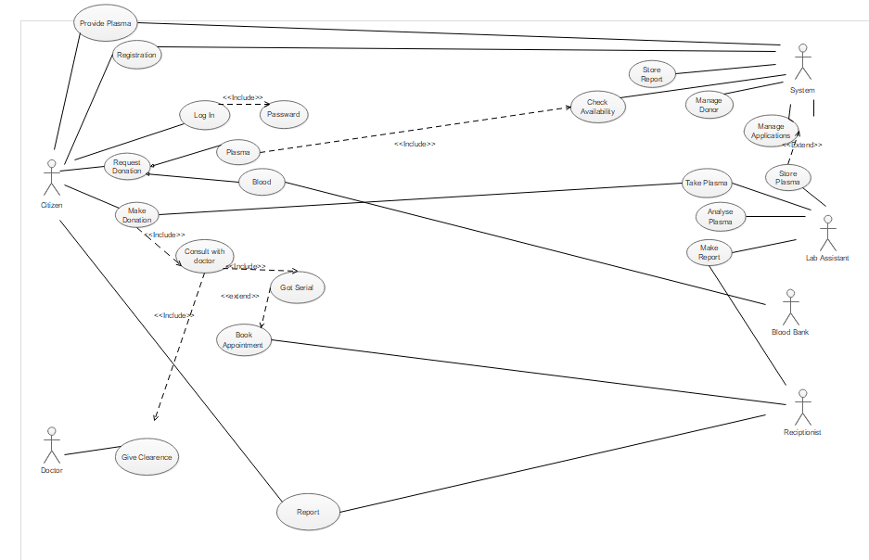**USE CASE Diagram:**

5. Class diagram of the project:

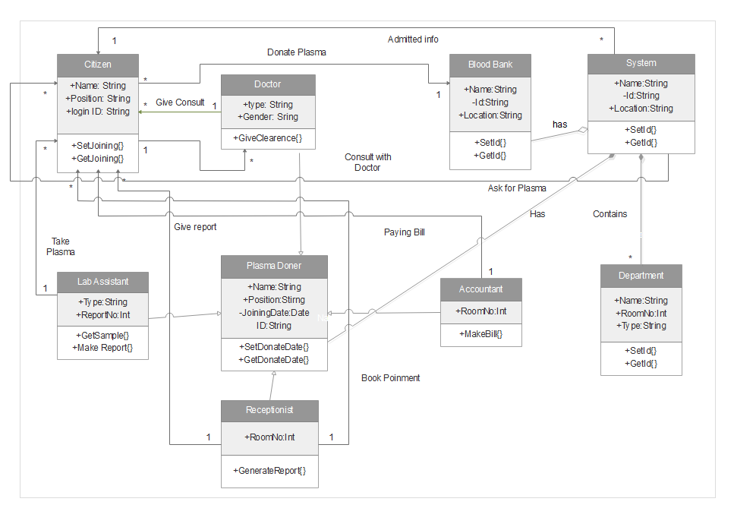6. Activity Diagram of the project:

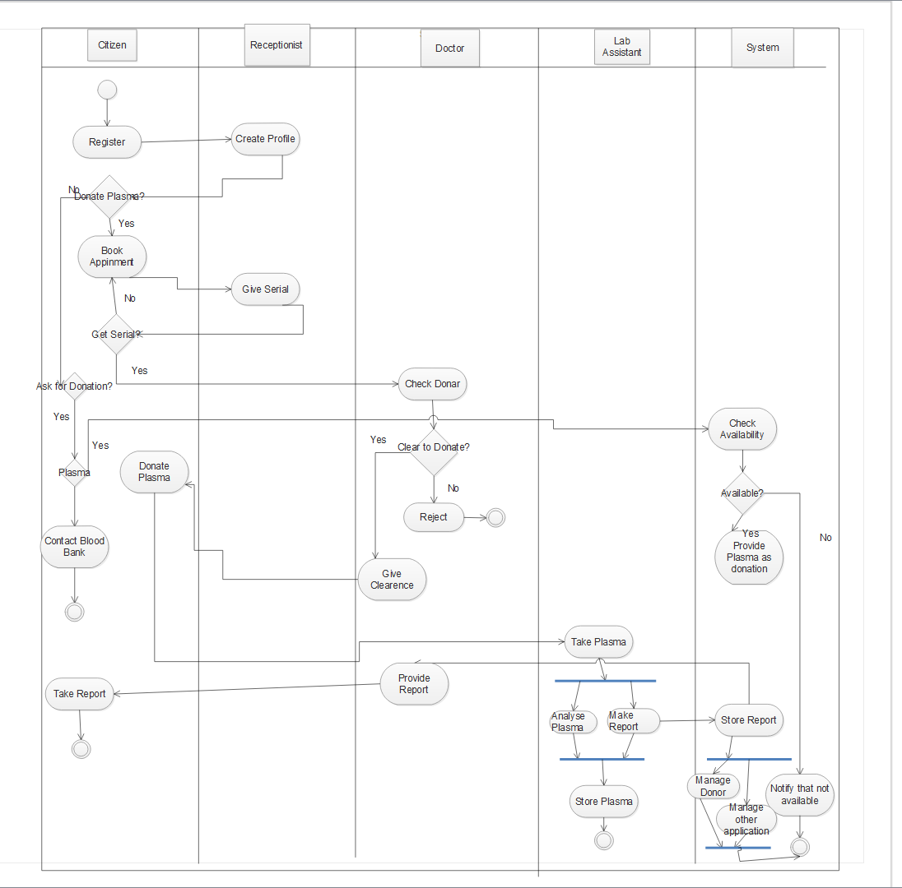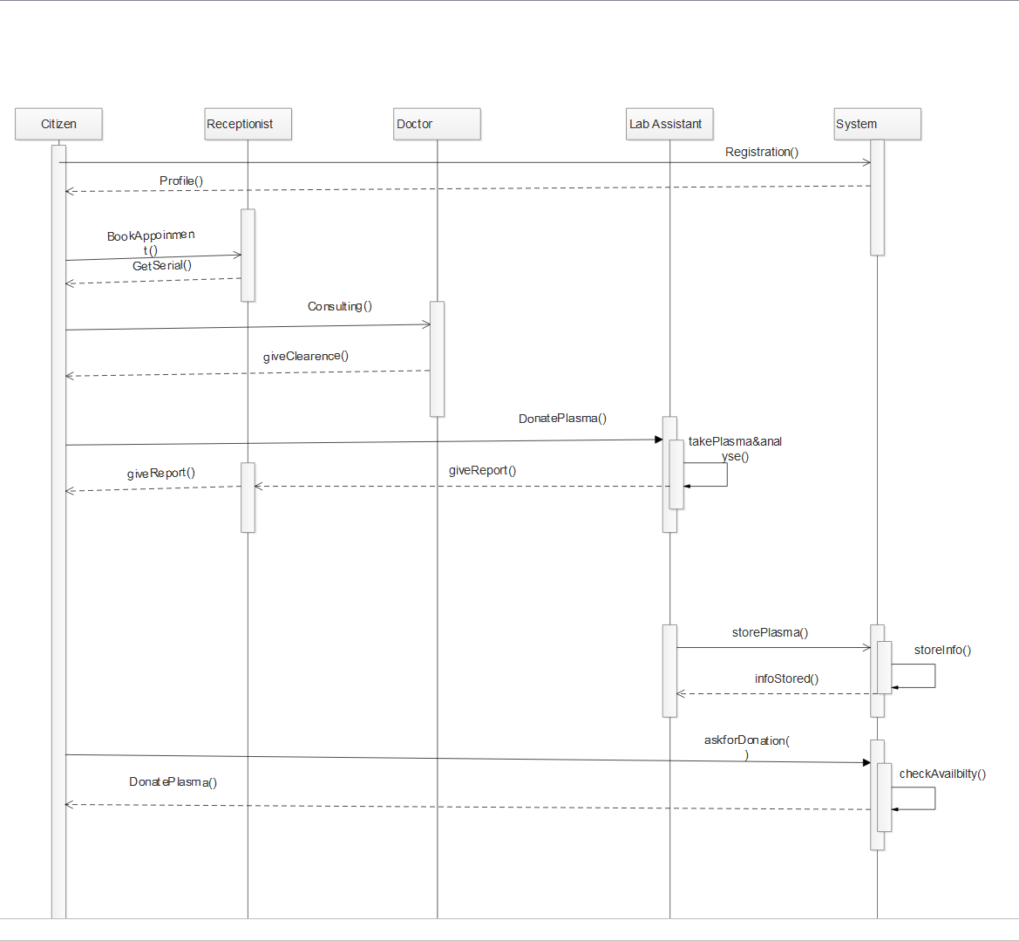7. Sequence Diagram of the project

8. Conclusion:

The purpose of the Plasma management system is to simplify and automate the process of searching for Plasma in case of emergency and maintain the records of plasma donors, recipients, plasma donation programs and plasma stocks in the system. With the help of our system we can prove that, a majority of the donors were willing to be regular donors. Here, the donors showed positive effects like a sense of satisfaction after the donation. It also creates an opportunity for plasma donation by conducting many plasma donation camps may increase the voluntary plasma donations. It also enables hospitals to record and store the data for people who want to communicate with them, and it also provides a centralized plasma bank database. In future, it could be a better system to donate plasma and also for storing all the information.